**Spike:** 2

**Title:** Non-Blocking Game Loop

**Author:** Parth Madhani , 101901858

**Goals / deliverables:**

* Code
  + Resources.h
  + WorldProcessor.h
  + WorldProcessor.cpp
  + MoveHandler.h
  + MoveHandler.cpp
  + Source.cpp

**Technologies, Tools, and Resources used:**

* Visual Studio 2017 IDE
* [www.cplusplus.com](http://www.cplusplus.com)
* Canvas

**Tasks undertaken:**

* Find out methods to implement non blocking game loop.
* Implementing a multi-thread design for the initial design from spike 1 as required for this task.

**What we found out:**

I found out mainly how to convert a simple loop into more complex game loop where there is no blocking that is the game can continue updating whilst waiting for input.

I implemented multi-thread design to the program and used it so that game waits for input only processing when it occurs.

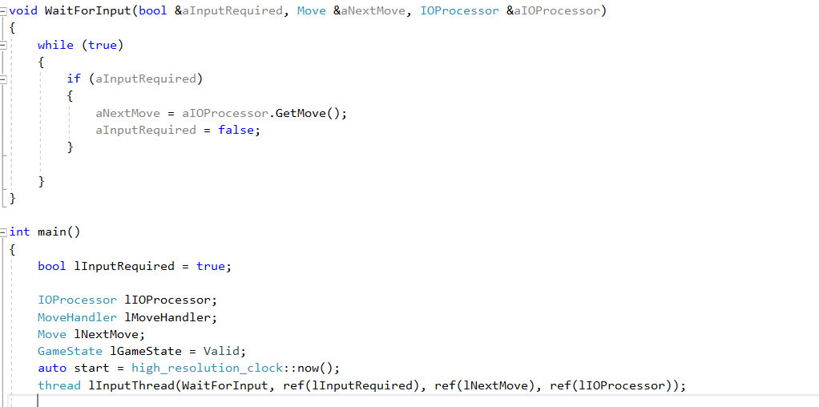

Additionally I just added timer to program so it calculates the time taken for the game to run / complete.

